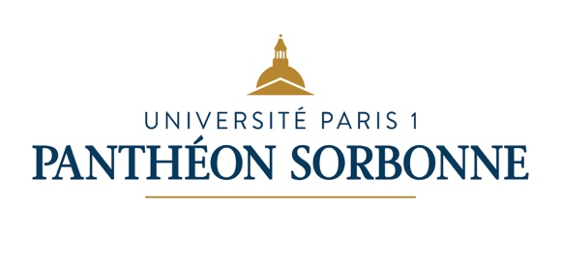



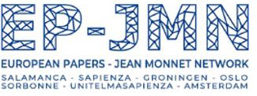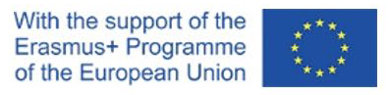

European Papers - Jean Monnet Network (EP-JMN)
Summer School 2022

Hosted by Paris 1 Panthéon-Sorbonne University, Law School
Paris, 6-10 September 2022

Rule of Law and Human Rights in Europe and the World in Times of Contestation

The last two decades have seen the emergence of numerous sites of resistance to the EU. The Greek opposition to austerity measures, the massive and EU-wide contestation of Covid-prevention measures, the gilets jaunes protest, not to mention the 2016 British referendum, are just a few examples of the increasing contestation of the EU integration, of - some of - its policies, and of their - perceived - impact on citizens’ rights. Such contestation, which has emerged in every member State, comes from social, political and judicial actors, from all sides of the political spectrum. The “rule of law crisis” has also shown the extent to which some Member States are questioning the way in which the EU defines the rule of law and the scope of its Human rights instruments. Moreover, contestation is both internal and external, in particular when non-EU actors question the way in which the EU applies, or imposes in its external relations, its conception of fundamental rights and of the rule of law.
The Paris EP-JMN Summer school lectures, which are mainly addressed to young scholars and PhD researchers, will take seriously the different expressions of contestation the European Union is facing. Contestation will be broadly defined, as the social practice of merely objecting to norms by rejecting them or by refusing to implement them. It is also a mode of critique through critical engagement in a discourse about these principles, rules, and values. The Summer School will thus address different but related topics. It will first ask what is the object of contestation: what the EU does or what the EU is? Is there enough space, in EU law, to institutionalize contestation? Lectures will also explore the rise of

contestation as a result of the way in which we “do” and we “think” integration. To what extent is our conception of the EU as an integration through law exposed to the different forms of contestation?
To address these questions, lectures will focus on Human rights and the rule of law in times of contestation. To what extent do Human rights and the rule of law frame contestation, or limit conflicts? Have EU Human rights law and EU Rule of law become the object of contestation? The Summer school will also explore some of the problems and challenges regarding the EU’s internal capacity for safeguarding human rights, the rule of law and democracy within its own Member States, and relating to its promotion of these values and principles on the international stage. It will examine how current contestation of the European project and of a rules-based and cooperative international order may affect the EU’s ability to promote and uphold its core values, both within and beyond its borders. The nature and impact of this multifaceted legitimacy crisis will be taken into account, looking into the constraints and opportunities this may hold for the EU as a global actor.
The lectures will endeavour to present very diverse perspectives, among which everyone can find its own way. The EP-JMN Paris Summer School, will gather PhD students and post-docs, junior and senior academics experts and practitioners in this domain. Lectures and exchanges are expected to provide a stimulating and challenging teaching and learning experience.
In addition to the four days of lectures, participants will be offered the opportunity to be active members of the PhD workshops, a place in which they are invited to present (in English or in French) their research and to discuss it with more experienced scholars. Young researchers will also be given the chance to exchange and reflect on legal thesis methodologies.
Finally on Saturday 10 September, a round-table will gather senior academics, practitioners of the EU institutions and members of the civil society. They will address the tensions between social and environmental justice in EU law.

The Summer school is organized with the help of the Institut de Recherche en Droit International et Européen de la Sorbonne (IREDIES), Paris 1 University



and with the financial support of the Erasmus + programme of the European Union

European Papers- Jean Monnet Network (EP-JMN)
Summer School, Paris, 6-10 September 2022

Programme

Tuesday 6 September

14,00-14,30 – Ségolène Barbou des Places, Commencement addresses
14,30-16,00 – Loïc Azoulai, Trouble and contestation in European law
16,30 –18,00 – Floris de Witte, Creating a space for contestation within the EU?

Wednesday 7 September

9,00-11,00 – Antoine Vauchez, Independence wars in the EU
11,30-13,00 – Laurent Pech, The EU’s limited capacity to impose Rule of Law internally

14,30-16,00 – Agustin J. Menendez, Which and Whose Rule of Law? The Struggle over the law of European integration
16,30-18,00 –Laurent Pech, Who in the EU defines/should define the Rule of law?

Thursday 8 September

9,00-10,30 – Elise Muir, Challenging the EU’s infrastructure for the protection and promotion of fundamental rights
11,00-12,30 – Sophie Robin-Olivier, What is missing in the EU catalogue of Human rights?

14,00-16,00 –Ramses Wessel, EU values and principles as part of the EU’s external action
16,30-18h00 – Edoardo Stoppioni, EU law and its others: Do EU values apply equally to all persons and States?

Friday 9 September

9,00-10,30 – Juan Santos Vara, The EU “double game” on the international scene: the example of migration
11,00-12,30 – Enzo Cannizzaro, Contestation of the EU as a rules-based and cooperative international order

14,00-18,00 – PhD workshops

Saturday 10 September

Round-Table: Articulating the protection of the environment and social rights in EU Law
with:

Katrin Langensiepen, MePs, European Parliament/ Group of the Greens
Tonia Novitz, University of Bristol (tbc)
Philippe Pochet, General Director of the European Trade Union Institute
Sophie Robin-Olivier, Professor of EU law at Paris 1 Panthéon-Sorbonne University
Franck Siebern-Thomas, European Commission, DG Employment

Call for application

Who’s concerned?

Master students, PhD researchers and post-doctoral researchers are encouraged to apply for the programme. Some prior knowledge of European law or EU institutions is useful, but a law degree is not required. Since all courses are taught in English, the applicant needs to be fluent in English to be able to understand the classes and to interact with fellow students and researchers.
Participants who will exchange on their own research during PhD workshops can make a presentation in French or in English.

Course fees

There is no tuition or registration fee for the programme. However, the summer school will not pay for living costs (accommodation, meals and transport) during your stay in Paris. After the admission, we will be happy to provide you with more information for your trip to Paris.

How to apply

- Application letter has to be sent to SummerSchoolParis2022@univ-paris1.fr before 10 July 2022.
The letter should include a CV, and a brief description of their thesis for researchers who are willing to discuss their PhD thesis with senior academics. A letter of recommendation is not required, but will be appreciated.

- The results of your application will be announced via email before 25 July.

